|  |  |
| --- | --- |
| **DATE** | 11 October 2022 |
| **TEAM ID** | PNT2022TMID42240 |
| **PROJECT NAME** | Personal Assistance For Senior Citizens Who Are Self Reliant |
| **PROJECT DESIGN PHASE 1** | Solution Architecture |

Solution Architecture:

Solution architecture is a complex process – with many sub-processes – that bridges the gap between business problems and technology solutions. Its goals are to:

* Find the best tech solution to solve existing business problems.
* Describe the structure, characteristics, behavior, and other aspects of the software to project stakeholders.
* Define features, development phases, and solution requirements.
* Provide specifications according to which the solution is defined, managed, and delivered.

.

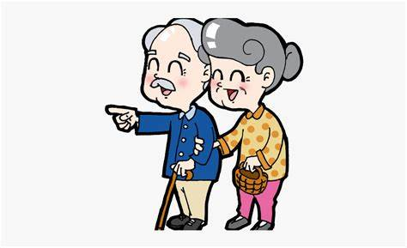

USER INTAKE

THE

MEDICINE

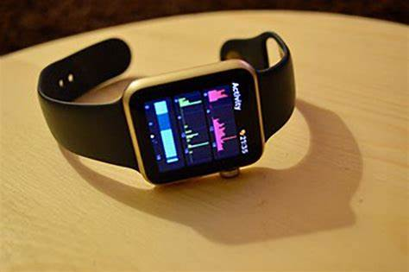

IOT DEVICE

SENSES ALARM



SENDS AN ALARM

SOUND



THE MAIN AIM OF THE

DEVICE IS TO TAKE

THE PILLS AT THE

RIGHT TIME



USER RECEIVES THE

SOUND



USER NOTICES THE

SOUND AND

REMAINDS



**USER ( SENIOR**

**CITIZENS)**



MEDICINES